**Ideation Phase**

**Define the Problem Statements**

|  |  |
| --- | --- |
| Date | 10 AUGUST 2025 |
| Team ID | PNT2025TMID09908 |
| Project Name | iRevolution: A Data-driven Exploration of Apple's iPhone Impact in India using Tableau |
| Maximum Marks | 2 Marks |

**Customer Problem Statement Template:**

Create a problem statement to understand your customer's point of view. The Customer Problem Statement template helps you focus on what matters to create experiences people will love.

A well-articulated customer problem statement allows you and your team to find the ideal solution for the challenges your customers face. Throughout the process, you’ll also be able to empathize with your customers, which helps you better understand how they perceive your product or service.

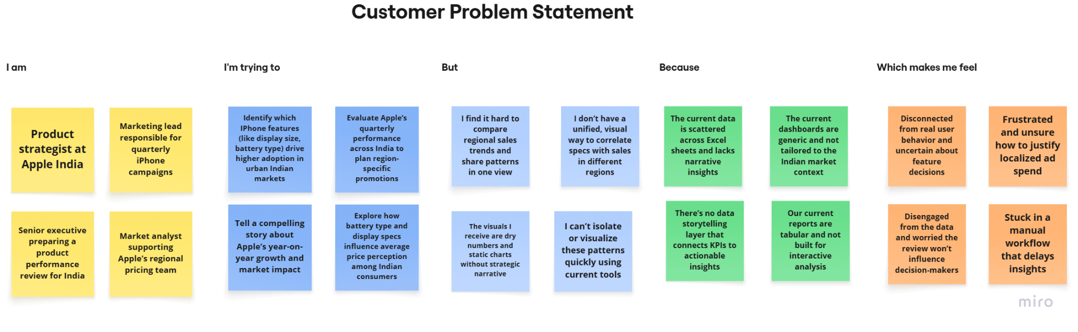

|  |  |  |  |  |  |
| --- | --- | --- | --- | --- | --- |
| **Problem**  **Statement (PS)** | **I am** | **I’m trying to** | **But** | **Because** | **Which makes me feel** |
| PS-1 | a product strategist | find which iPhone features drive adoption in urban India | data is scattered and not visual | there's no unified dashboard | unsure about feature decisions |
| PS-2 | a marketing lead | track regional performance for iPhone campaigns | I can’t  compare trends across quarters and states | dashboards aren’t  India-specific | frustrated and uncertain on  promotions |
| PS-3 | Senior executive | present iPhone growth in  India clearly | reports lack storytellin g and visual appeal | there’s no narrative-dri ven dashboard | disengaged and ineffective |
| PS-4 | market analyst | link features like battery/displ ay to price | I can’t visualize patterns easily | tools are static and not interactive | slowed down and stuck |